**Task 1: Complete the tables**

|  |  |  |  |  |
| --- | --- | --- | --- | --- |
| **Input**  **Reference** | A B C | F | **Min term** | **Max term** |
| **0** | 0 0 0 | 0 |  | M0=A+B+C |
| **1** | 0 0 1 | 1 | m1=A’B’C |  |
| **2** | 0 1 0 | 1 | m2=A’BC’ |  |
| **3** | 0 1 1 | 0 |  | M3=A+B’+C’ |
| **4** | 1 0 0 | 0 |  | M4=A’+B+C |
| **5** | 1 0 1 | 0 |  | M5=A’+B+C’ |
| **6** | 1 1 0 | 1 | m6=ABC’ |  |
| **7** | 1 1 1 | 0 |  | M7=A’+B’+C’ |

**Table C.1 Truth table to a combinational circuit**

|  |  |  |
| --- | --- | --- |
|  | **Shorthand Notation** | **Function** |
| **1st Canonical**  **Form** | F= Σ (1,2,6) | F = A’B’C+ A’BC’+ ABC’ |
| **2nd Canonical**  **Form** | F= Π (0,3,4,5,7) | F =( A+B+C).( A+B’+C’).( A’+B+C).( A’+B+C’).( A’+B’+C’) |

## Table C.2 1st and 2ndcanonical forms of the combinational circuit of Table C.1

Task 2: Attach the **1st Canonical Form** circuit diagram of the combinational circuit of Table C.1

Task 3: Attach the **2nd Canonical Form** circuit diagram of the combinational circuit of Table C.1

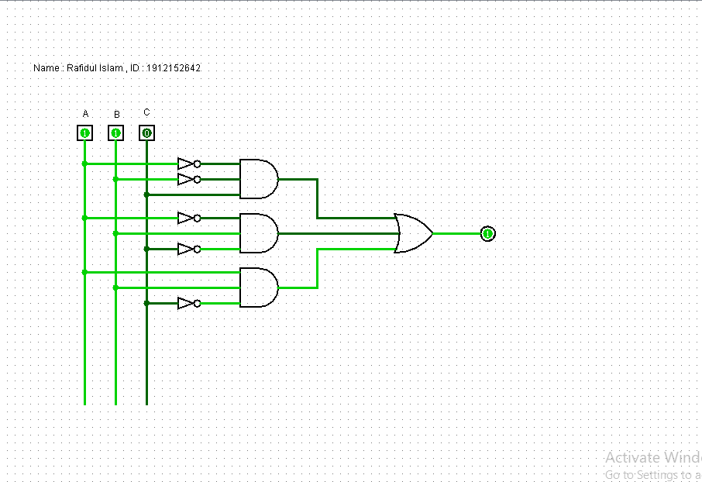

**Task 2 : *1st Canonical Form***

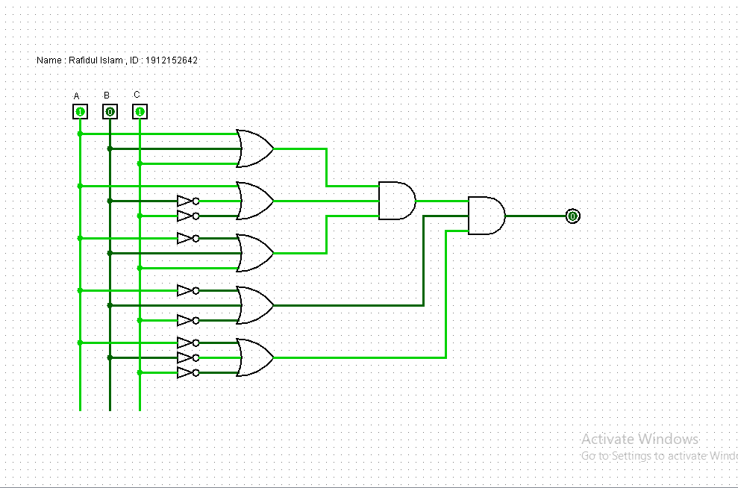

**Task 3 : *2nd Canonical Form***